**Problem Statement:**

* At 8:30am we want to take the backup of DB.
* At 8:40am we want to upload DB backup to gdrive and delete previous backup from gdrive.
* At 5:30pm again take db backup.
* At 5:40pm upload db backup to gdrive and delete previous backup from gdrive.

### **Prerequisites**

**Install mongodb or mongod** for MongoDB backups:

**Install rclone** to interact with Google Drive:  
sudo apt-get install -y rclone

Configure rclone with Google Drive by running:  
rclone config

1. Follow the prompts to set up access to your Google Drive and name it (e.g., gdrive).

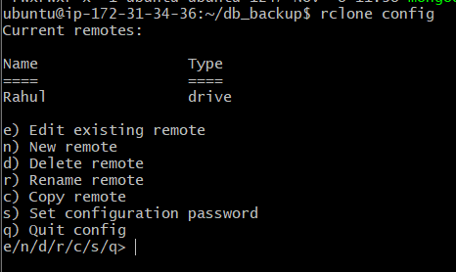

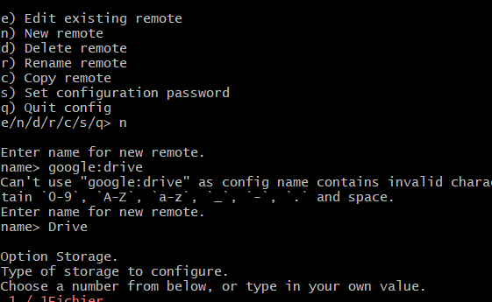

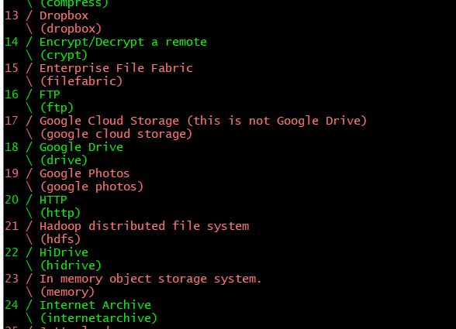

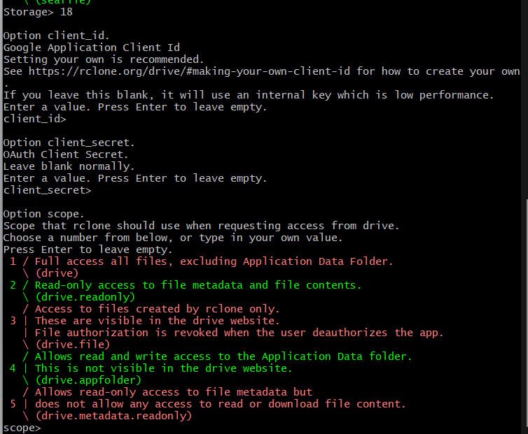

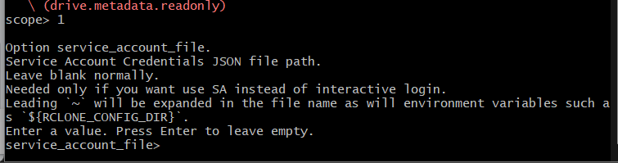

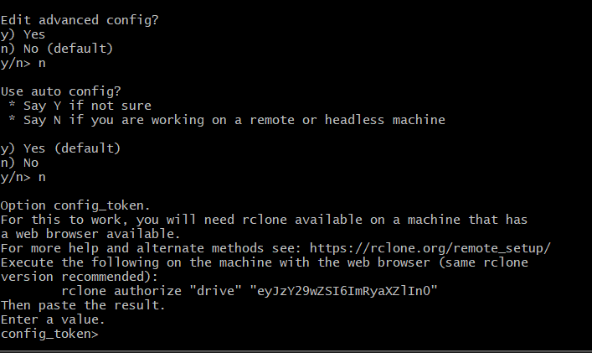

Install rclone for windows

<https://rclone.org/downloads/>

Extract the file.

Without path set

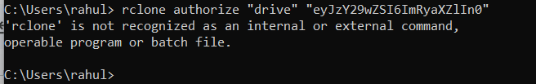

Set the path into environmental variable.

OR

set path=” ”

For that particular terminal

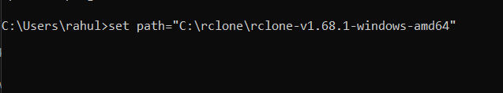

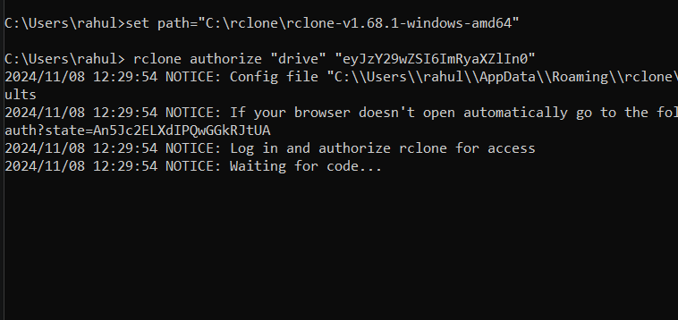

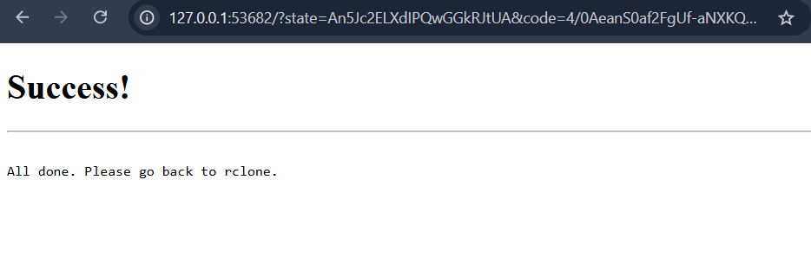

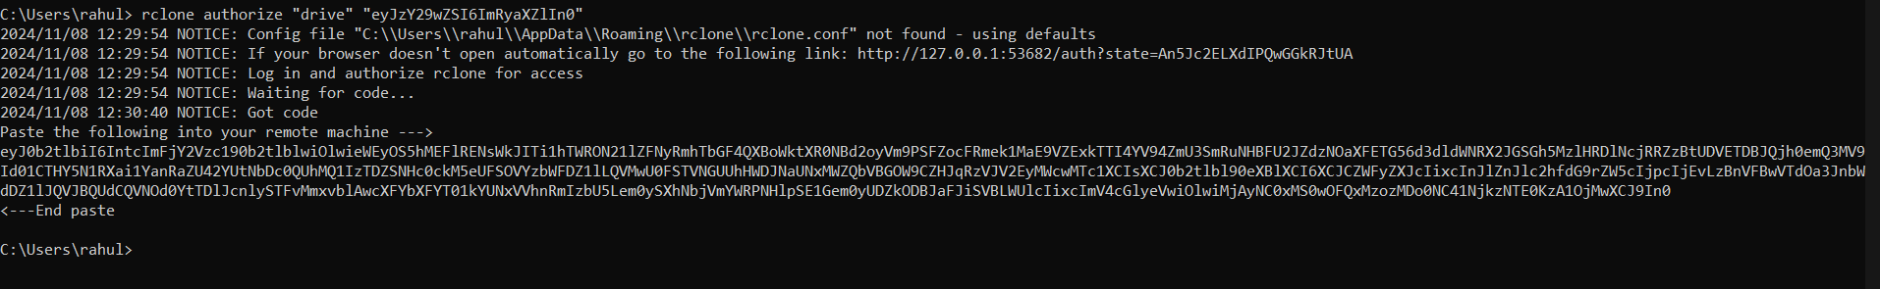

Paste the following into your remote machine --->



<---End paste

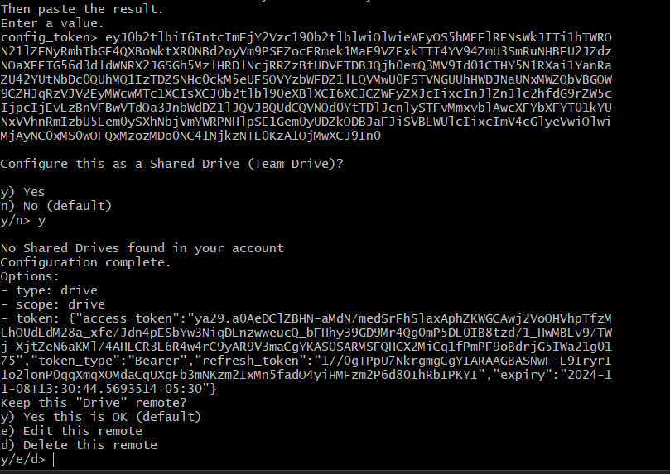

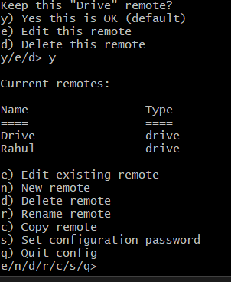

T**his bash script will create .zip file**

#!/bin/bash

# Define directories

LOCAL_BACKUP_DIR="/var/backups/mongodb"

GDRIVE_DIR="Rahul:mongodb_backups" # Use "Rahul" as the remote name

DATABASE_NAME="your_database_name"

# Log file

LOG_FILE="${LOCAL_BACKUP_DIR}/mongodb_backup.log"

# Get current time

current_time=$(date +"%H:%M")

# Determine backup file based on the time

if [ "$current_time" == "11:40" ]; then

backup_time="11_40"

delete_time="10:28"

elif [ "$current_time" == "10:16" ]; then

backup_time="10_16"

delete_time="08:40"

else

echo "This script should only run at 8:30 AM or 5:30 PM."

exit 1

fi

# Step 1: Take MongoDB backup

backup_dir="${LOCAL_BACKUP_DIR}/${backup_time}_backup"

mongodump --db "$DATABASE_NAME" --out "$backup_dir"

# Remove any extra files in the target directory to avoid accidental uploads find "$backup_dir" -type f -name "*.sh" -delete

# Step 2: Compress the backup directory into a .tar.gz file

backup_file="${LOCAL_BACKUP_DIR}/${backup_time}_backup.zip"

zip -r "$backup_file" "$backup_dir" .

# Step 3: Delete the backup directory after compression

rm -rf "$backup_dir"

# Step 4: Delete the previous backup from Google Drive

rclone delete "${GDRIVE_DIR}/${delete_time}_backup.zip"

# Step 5: Upload the new compressed backup to Google Drive

rclone copy "$backup_file" "${GDRIVE_DIR}/${backup_time}_backup.zip"

echo "Backup for ${backup_time} completed, compressed, and uploaded to Google Drive."

**This bash script will directly make db copy and upload files directly to gdrive but not in zip**

#!/bin/bash

# Define directories

LOCAL_BACKUP_DIR="/var/backups/mongodb"

GDRIVE_DIR="Rahul:mongodb_backups" # Use "Rahul" as the remote name

DATABASE_NAME="your_database_name" # Specify the database to back up

# Log file

LOG_FILE="${LOCAL_BACKUP_DIR}/mongodb_backup.log"

# Get current time

current_time=$(date +"%H:%M")

# Determine backup time based on the time

if [ "$current_time" == "15:47" ]; then

backup_time="15_47"

delete_time="17_40"

elif [ "$current_time" == "17:30" ]; then

backup_time="17_30"

delete_time="8_40"

else

echo "This script should only run at 8:30 AM or 5:30 PM." | tee -a "$LOG_FILE"

exit 1

fi

# Step 1: Take MongoDB backup of the specific database

backup_dir="${LOCAL_BACKUP_DIR}/${backup_time}_backup"

mongodump --db "$DATABASE_NAME" --out "$backup_dir" # Backup only the specified database

# Remove any extra files in the target directory to avoid accidental uploads

find "$backup_dir" -type f -name "*.sh" -delete

# Step 2: Clear previous backups in Google Drive

rclone purge "${GDRIVE_DIR}"

# Step 3: Upload only the MongoDB backup directory to Google Drive

rclone copy "$backup_dir/$DATABASE_NAME" "${GDRIVE_DIR}/${backup_time}_backup" --create-empty-src-dirs

# Log success

echo "Backup for ${backup_time} of database '${DATABASE_NAME}' completed and uploaded to Google Drive." | tee -a "$LOG_FILE"

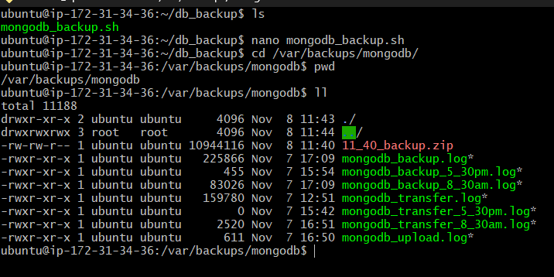

Set all the permissions for ubuntu user.

Run the cmd

crontab -e

# Backup at 8:30 AM and 5:30 PM

40 11 * * * /home/ubuntu/db_backup/mongodb_backup.sh # Backup at 8:30 AM

16 10 * * * /home/ubuntu/db_backup/mongodb_backup.sh # Backup at 5:30 PM

#Delete old backup and upload new backup at 8:40 AM and 5:40 PM

40 11 * * * rclone delete Rahul:mongodb_backups/10_28_backup.zip && rclone copy /var/backups/mongodb/8_30_backup.zip Rahul:mongodb_backups/8_30_backup.zip

17 10 * * * rclone delete Rahul:mongodb_backups/8_40_backup.zip && rclone copy /var/backups/mongodb/17_30_backup.zip Rahul:mongodb_backups/17_30_backup.zip

Change time according in cron job and also .sh file .

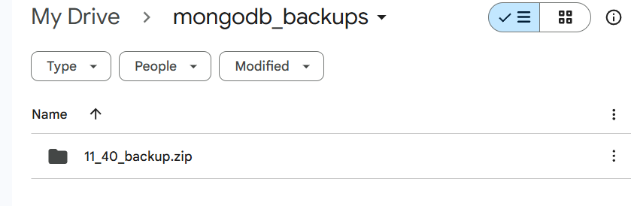

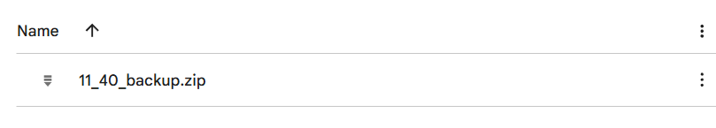

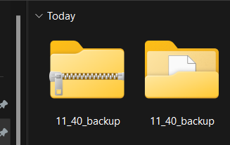



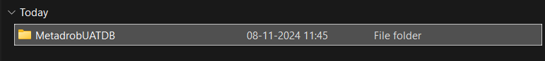

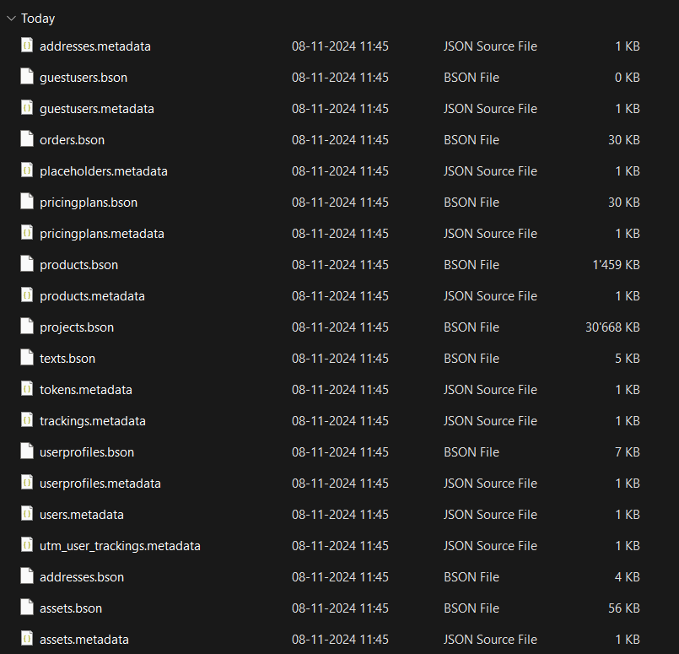

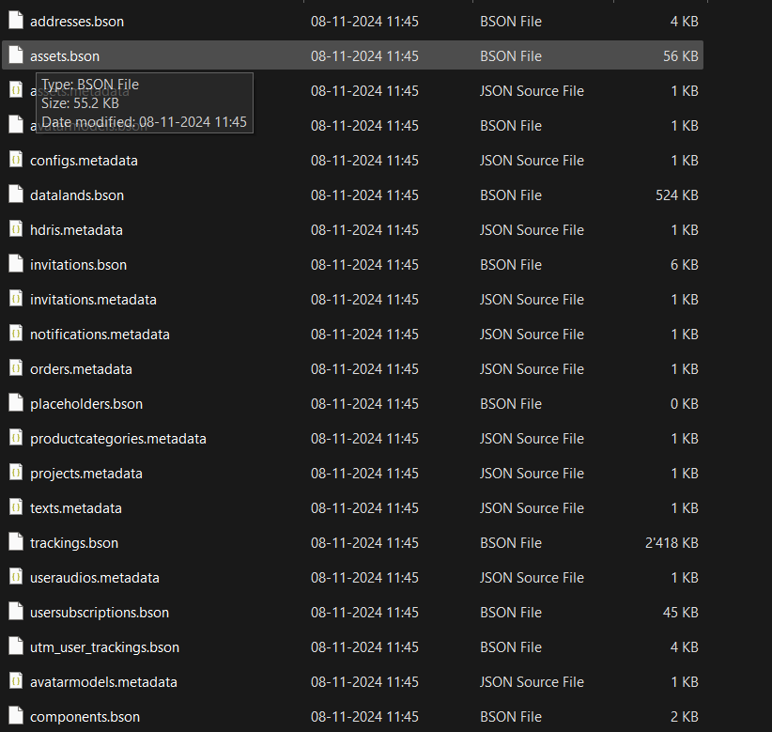

Total 56 time and 28 collection

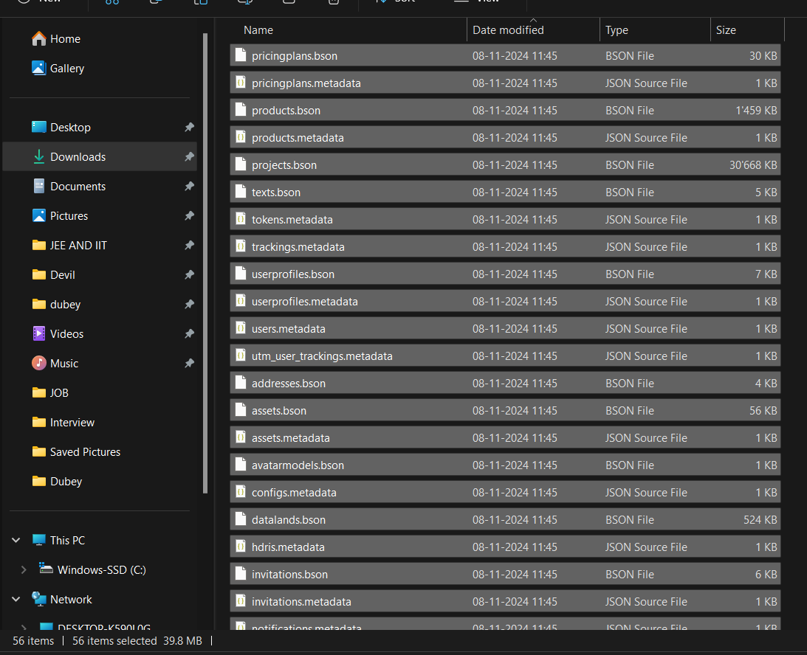

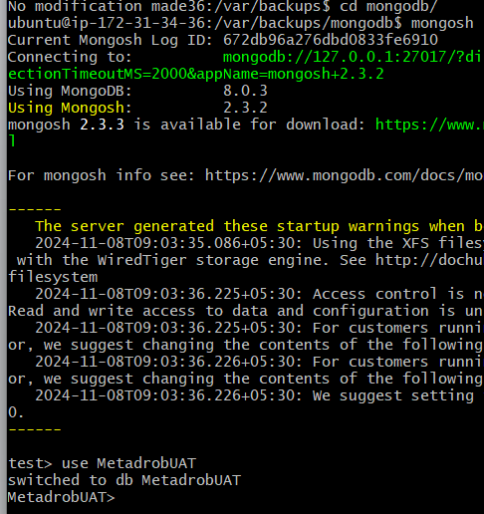

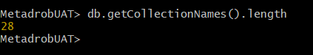

Note:

* Set the required permission to run the job also for the .sh file.
* Set the required permission for ubuntu user to transfer file from local to gdrive and execute all the cmd.
* Check the time of ubuntu as IST no UTC.
* Change the time in .sh and cron job according to requirements.